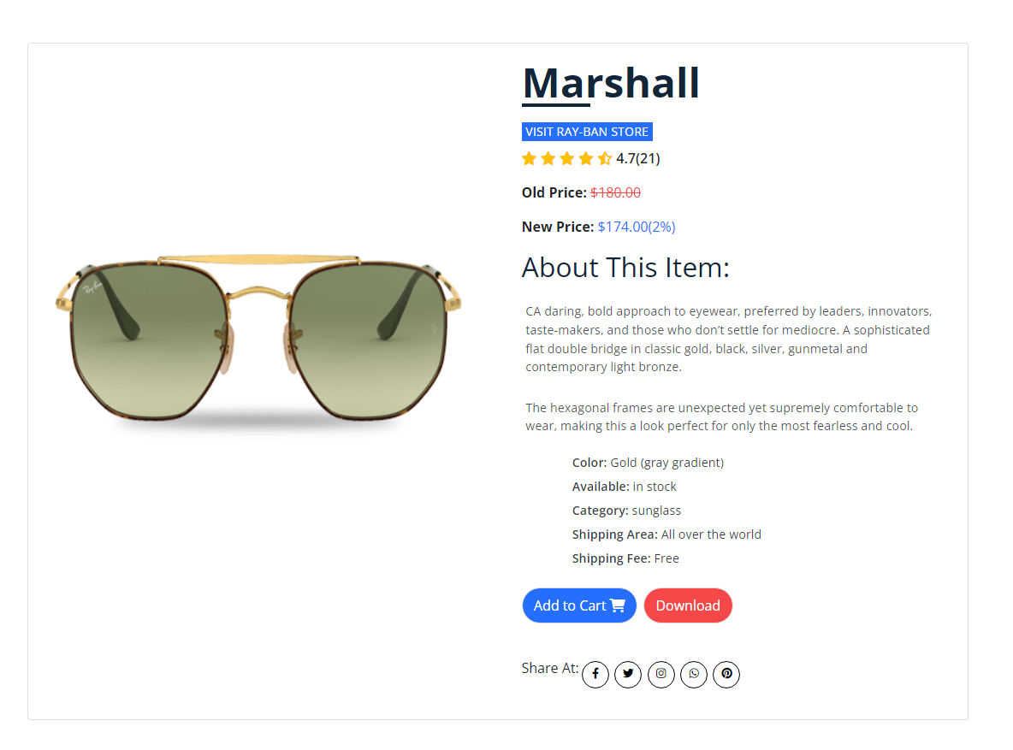
Product Detail
Featuring geometric lenses and full-metal construction, this hexagonal frame is a look that soars above the rest. With its double bridge and multiple gold, black and Havana colorways, this Marshal-inspired look expresses a bold personality.

