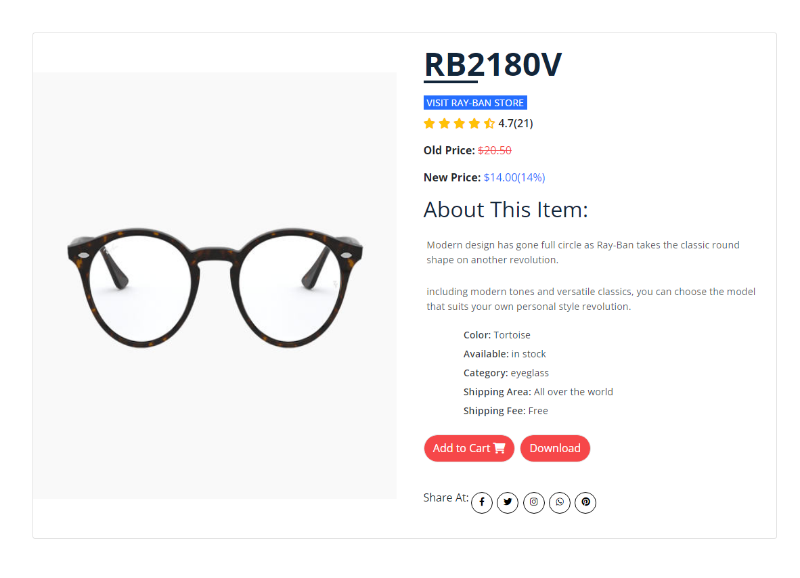
Modern design has gone full circle as Ray-Ban takes the classic round shape on another revolution. Along with distinctive rivets and Ray-Ban shaped temples, these styles feature a sleek flattened bridge and stylish round lenses. With cool colors on offer, including modern tones and versatile classics, you can choose the model that suits your own personal style revolution.
Product Details

