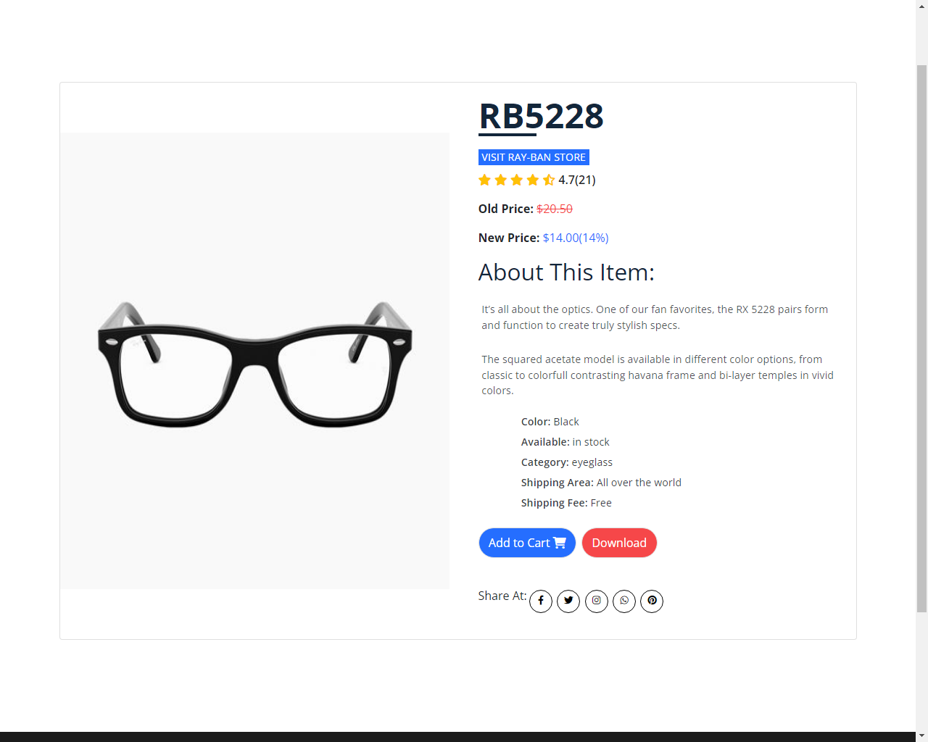

It’s all about the optics. One of our fan favorites, the RX 5228 pairs form and function to create truly stylish specs. The squared acetate model is available in different color options, from classic to colorful contrasting Havana frame and bi-layer temples in vivid colors.

**Product Details**