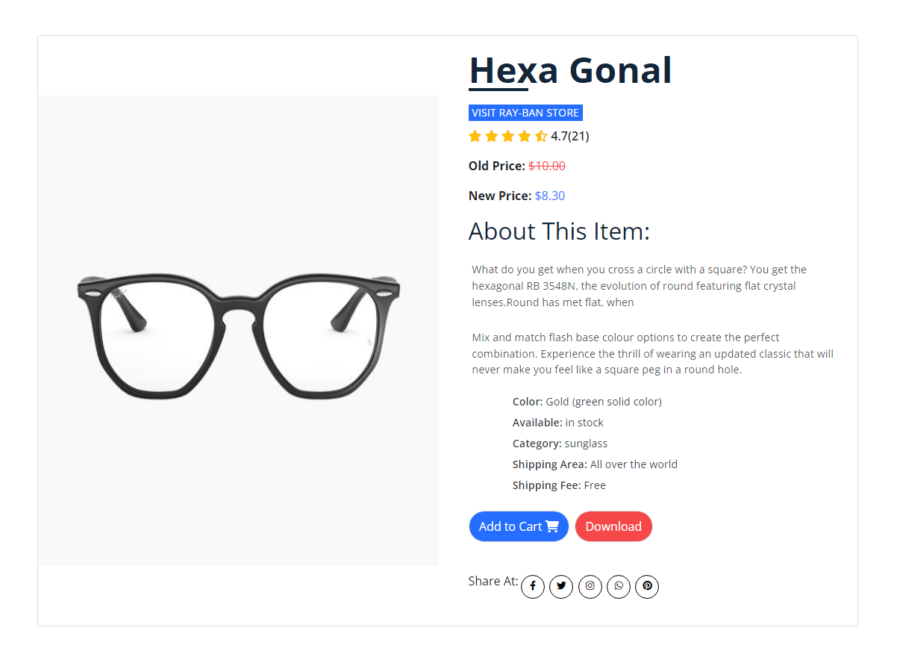
Inspired by one of Ray-Ban's best sellers, hexagonal lands into Optical. With flat temples and embossed logos, they promote a minimalist look. Timeless elegance in a new softly hexagonal shape. Choose the classic gold, silver and black metals, as well as enamel effects.
Product Details

